P R A C T I C A L W O R K # 1. Horizontal and vertical measurements (22nd April, 2021)

- Linear dimensions
The web page shows the key dimensions of the Airbus A380 in metres, and the explanations below it describe how they are measured. In the explanations, the word plane means an imaginary surface (not an aeroplane). On drawings, planes are shown as lines that indicate where dimensions are measured from and to, and are positioned to strike (touch) the faces (edges or surfaces) of components. Often, they are either horizontal planes or vertical planes.

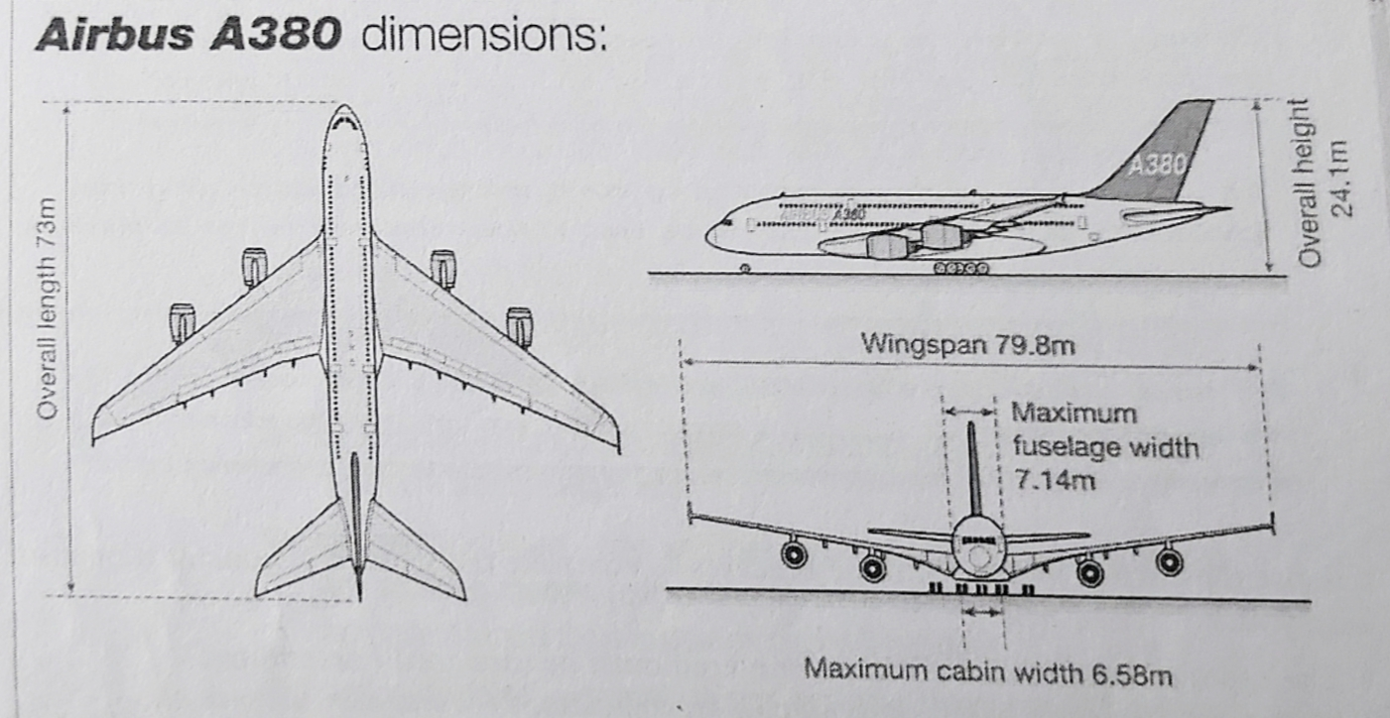

Overall length is a measurement of how long the aircraft is in total. The measurement is taken between the two points that are furthest apart (the front and rear extremities), along the length of the aircraft. The length is measured along a horizontal plane. It is the distance between a vertical plane striking the front of the nose, and a vertical plane striking the rear of the tail.
Wingspan is the total distance spanned by both wings. The span is measured as a straight line between the two wingtips.
Overall height measures how tall the aircraft is. The dimension is measured vertically between the underside of the wheels and a horizontal plane striking the top of the tail.
Maximum fuselage width is the external width of the aircraft's body- how wide it is, measured horizontally between vertical planes striking the outside faces of the fuselage.
Maximum cabin width states the maximum internal width, measured between the inside faces of the fuselage. The measurement is equivalent to the external width, less the thickness of the fuselage at each side of the aircraft.

Notes: When written, the words dimension and dimensions are often abbreviated to dim and dims. Span is also used to describe the distance(s) crossed by a bridge, between its supports. If a bridge has a support at its centre (as well as at each end), then it has two spans.

B-Level and plumb
If a surface is described as being level, this means it is both horizontal and flat (smooth). However, a surface which is flat is not necessarily horizontal. A flat surface may be vertical, or inclined (sloping at an angle to the horizontal or vertical plane).
Faces that are vertical, such as those of the walls of buildings, are described by engineers as being plumb. Structures that are slightly inclined from vertical are said to be out of plumb.

A C T I V I T I E S

Act. 1: Complete the key dimensions of the Millau Viaduct in France, using the words in the box. Look at A opposite to help you.

height overall thickness span width

1) ................................ length: 2,460 m
2) Maximum ................................ between supports: 342m
3) ................................ of tallest support (ground to deck): 245m
4) ................................ of deck: 32m
5) ................................ of deck: 4.2 m

Act. 2: Decide whether the sentences about the viaduct are true or false, and correct the false sentences. Look at A and B to help you.
1) The height of the towers is measured horizontally.
2) The overall span is measured along the width of the bridge.
3) The tops of the towers are at different levels, so a horizontal plane striking the top of one tower will not strike the tops of all the others.
4) The highest point of the structure is the top extremity of the highest tower.
5) The thickness of each tower decreases towards the top, so the faces of the towers are plumb.
6) The greatest thickness of each tower is its internal thickness at its base.

Act. 3: Choose the correct words to complete the text about extra-high voltage (EHV) power lines. Look at A and B to help you. The first one has been done for you.
On EHV transmission lines, cables- called conductors- (1) incline / span between pylons, which are described as supports. The conductors are suspended from the supports by rods, called insulators. On straight sections of line, the insulators are (2) level / plumb, hanging vertically from the supports. At supports where the direction of the line changes, pairs of insulators are used. In this situation, the insulators are (3) inclined / striking from the vertical plane, as they are pulled (4) plumb / out of plumb by the conductors pulling in different directions.
The higher the voltage being transmitted by the line, the greater the required distance between the conductor and the support, in order to provide effective insulation. The (5) length / width of insulators therefore varies, depending on the voltage. Higher voltages also mean that conductors must be located at a greater minimum (6) height / thickness above the ground, for safety. This distance is measured between the ground and the lowest point of the cable.
Act. 4: Read the text below. Can you answer the questions?
On long suspension bridges, when the distance between the vertical centres of the towers at either side of the bridge is measured horizontally, the distance between the tops of the two towers will be several millimetres longer than the distance between their bases.
1- Does this mean the towers are out of plumb?
2- Why is there a difference?

