Practical Work # 3: Moving parts
(10th June class)
A - Angular motion
If a spanner is used to tighten a bolt, one end remains in the same position on the bolt, while the other end turns. This type of motion, where one end of a component pivots while the other end follows the arc of a circle, is called angular motion. An example is a flap on an aircraft wing, which can be moved to different positions. The point at the centre of angular motion is called the axis of rotation (or axis). We say that the motion occurs about the axis (around it).
The speed of angular motion is measured as angular velocity, and increases in angular velocity are measured as angular acceleration.

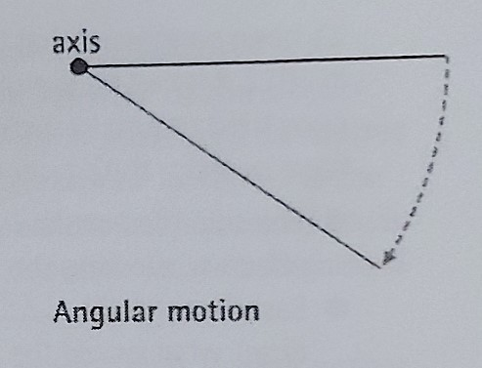

B - Rotary and reciprocating motion
When angular motion is through 360 degrees, it is called a revolution (or rotation). When moving parts of machines, such as wheels, turn through complete revolutions - once, several times, or for continuous periods- we say they revolve (or rotate). The rotational velocity of revolving parts, or rotating parts, is measured in revolutions per minute (rpm) - often called revs per minute. The motion of revolving parts is called rotary motion.
Rotary motion generates centrifugal force- that is, force which pushes outwards, away from the axis of rotation. An increase in rotational velocity results in a higher centrifugal force.
Some components move backwards and forwards. This type of motion is called reciprocating motion (or reciprocating action)- the component reciprocates. In machines, reciprocating motion is often converted (changed) to rotary motion. An example is a piston.

C - Engine revs
The abbreviation for revolution - rev - is widely used to talk about engines. For example:
• The rotational velocity of an engine is measured by a rev counter.
• High and low engine speeds are described as high revs and low revs.
• Maximum engine speed can be controlled by a rev limiter.
• If an engine's rev limit is exceeded, we say the engine is over-revved.
• An engine designed to run at high speed is a high-revving engine.
• When engine speed is increased momentarily, we say the engine is revved (or revved up).
• We can say an engine is revved to a certain speed - for example, revved to 6,000 rpm.

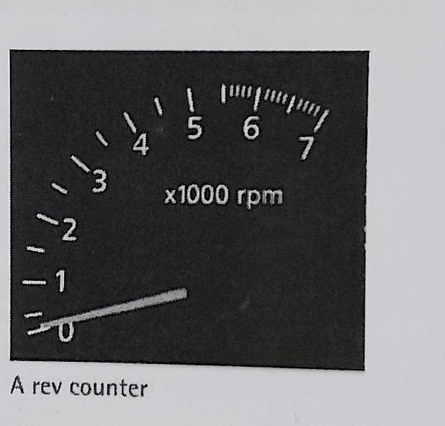

D - Friction
Moving parts cause friction. Friction is the force of resistance when two surfaces slide against each other. Frictional resistance is measured as the coefficient of friction. This is the force required to overcome friction in order to allow an object made of a specific material to slide along the surface of another specific material.
There are two types of friction. Static friction -sometimes called stiction - is the frictional resistance between two surfaces that are at rest (not moving). It measures the force needed to start a sliding action. Dynamic friction is the friction between two surfaces that are already sliding against each other. It measures the force needed to keep a sliding action going. More force is needed to overcome static friction than to overcome dynamic friction.

A C T I V I T I E S

Activity 1: Match the descriptions (1- 6) to the terms (a-f). Look at A and B to help you. (Una las descripciones (1-6) a las expresiones (a-f). Mire los textos A y B por ayuda)
- the speed of movement of a part which turns around a point
- pressure, exerted in an outward direction, due to rotary motion
- the rate of increase of speed of a part which turns around a point
- the point about which a part turns
- a turning movement
- movement backwards and forwards

- angular motion
- angular velocity
- angular acceleration
- axis of rotation
- reciprocating motion
- centrifugal force

Activity 2: Complete the sentences using suitable forms of the words “revolve or rotate”. Sometimes forms of both words are possible. Look at B to help you. The first one has been done for you. (Complete las oraciones usando formas de las palabras “revolve y rotate”.A veces las formas de ambas palabras es posible. Mire el texto B por ayuda. El primero ha sido hecho para ud.)
- The measurement of rotational velocity is rpm.
- As you can see, the wheel ................................................ at extremely high velocity.
- A recording device counts each ................................................ of the wheel.
- High-velocity ................................................ motion causes vibration.
- This wheel is the biggest ................................................ part in the machine.
- What's the speed of the turbine in ................................................ per minute?
- The braking system ensures the wheel ................................................ slowly.

Activity 3: Complete the description of an engine problem using words from C. (Complete la descripción del problema de un motor usando palabras del texto C)
Normally, the engine shouldn't be able to run faster than its maximum 1) ............................ ................................ of 8,000 rpm. The 2) ............................... ................................ should prevent it from exceeding that limit. But something went wrong, because according to the reading on the 3) .............................. ..............................., the engine 4) ............................... ................................ 10,500 rpm - so it was 5) ............................... - ................................ by a significant margin. And since it’s not supposed to be a 6)……………….. - ……………. engine, it’s not designed to cope with those kinks of speeds.

Activity 4: Find expressions in text D with the following meanings. (Encuentre expresiones en el texto D con los siguientes significados)
- the measurement of friction.
- the frictional resistance between surfaces that are already sliding against each other.
- the frictional resistance between surfaces that are not yet sliding against each other.

Send the complete work to be checked by email.
Deadline: 17th June, 2021

