PRACTICAL WORK # 2. DIMENSIONAL ACCURACY
(20th May class)
- Precision and tolerance
It is impossible to produce components with dimensions that are absolutely precise, with sizes exactly the same as those specified in a design. This is because all production processes are imprecise to a certain extent. Therefore, the sizes of several components produced from the same design will vary (differ). Although the variation may only be a few hundredths of a millimetre, sizes will not be 100% accurate (exact) compared with the design.

Because engineers know that accuracy cannot be perfect, in designs they often specify tolerances -that is, acceptable variations in precision. Instead of giving one precise size, a tolerance specifies a range of acceptable sizes- an allowed amount of variation. This is often given as a deviation (difference) from a precise size.

The drawing below shows a shaft with a specified diameter of 88 mm, plus or minus (±) 0.05 mm. This means the diameter may deviate 0.05 mm either side of this size. Therefore, diameters of 87.95 mm and 88.05 mm, which are slightly inaccurate, are still permissible (allowed), as they are within tolerance. However, diameters of 87.94mm or 88.06mm are not permissible- they are outside tolerance.

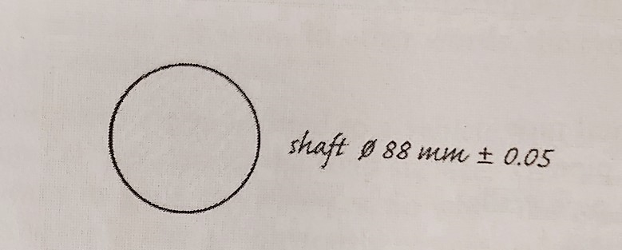
When the permissible deviation in size is very small, we say it is a tight tolerance (or a close tolerance). A large permissible deviation is a loose tolerance. For example:
• Machining a metal component to a tolerance of ±0.1 mm is relatively easy to do, so this tolerance is loose. But a tolerance of just ±0.01 mm is a tight tolerance in metalworking.
• In a concrete structure, ±10mm is a loose tolerance. But ±1mm is tight, because it is difficult to place wet concrete accurately.

- Fit
When one component goes through another, such as a shaft or a bolt going through a hole, the two must fit together- their sizes and shapes must match. The key question is, how tightly (or loosely) should they fit together? There are two main types of fit:
• A clearance fit allows a component to slide or turn freely, by leaving clearance (a gap) between itself and the sides of the hole. This distance must be quite precise. If there is insufficient clearance - if the gap is too small - the component will fit too tightly. As a result, the component will bind - it will not be able to slide or turn freely. In other words, there will not be enough play. However, if there is too much clearance, there will be too much play and the component will be able to move too much.

• An interference fit is a very tight fit which does not allow a component to move freely inside a hole. This type of fit can be achieved by forcing the component into the hole. Alternatively, the metal around the hole can be heated so that it expands (increases in size due to heat). After sufficient expansion, the component is placed in the hole. The metal then cools and contracts (decreases in size due to cooling). The contraction results in a tight fit. An example of an interference fit is a train wheel fitted on an axle.

Activity 1: Find words and expressions in text A with similar meanings to the words and expressions below (1-10). Sometimes there is more than one possible answer. The first one has been done for you.

- allowed permissible
- exact ………………………………..
- differ ……………………………………..
- exactness …………………………………
- not exact ……………………………
- deviation between maximum and minimum ……………………………….
- an acceptable deviation ……………………………………….
- an unacceptable deviation ……………………………………………
- little deviation allowed …………………………………………
- large deviation allowed …………………………………………..

Activity 2: Match the related sentences. Look at text B to help you.
- It'll bind. a) The bolt will have to turn in the hole.
- It'll contract. b) The bolt won't be able to turn freely enough in the hole.
- It'll expand. c) The bolt won 't fit tightly enough in the hole.
- There'll be too much play. d) The wheel will have to fit very tightly on the axle.
- It needs a clearance fit. e) The hole will widen with the high temperature.
- It needs an interference fit. f) The shaft will shorten and narrow slightly as it cools.
Note: will (auxiliar de tiempo futuro) – will have: tendrá – won’t fit: no encastrará.

Activity 3: Complete the article about engine blueprinting using the words in the box. Look at A and B to help you.
clearances - fit - minus - permissible - plus - range – precise - tolerances - variation - within

Blueprinting for performance
The advantage of racing in a kart class with a standard engine spec seems obvious - everyone has the same power, so it's driving talent that makes the difference. But things aren't quite that simple. No two standard engines are identical. There will always be a slight (1) ................................ in the size of engine parts, since they are manufactured, not to perfectly (2) ................................ dimensions, but to specified (3) ................................. Although these differences may only be (4) ............................. or (5) ............................. a few hundredths of a millimetre, they will nevertheless result in a slight performance gap between any two engines.
One way round this problem (if you have the cash) is to have your engine blueprinted. The process is perfectly legal, as the sizes of all parts remain (6)................................the tolerances that are (7) ................................for the standard engine specification. However, by carefully matching pairs or groups of parts that are all in either the lower or upper half of the tolerance (8)................................ , a blueprinted engine is built to (9) ...............................together very precisely, thanks to almost perfect (10) ................................between moving parts.

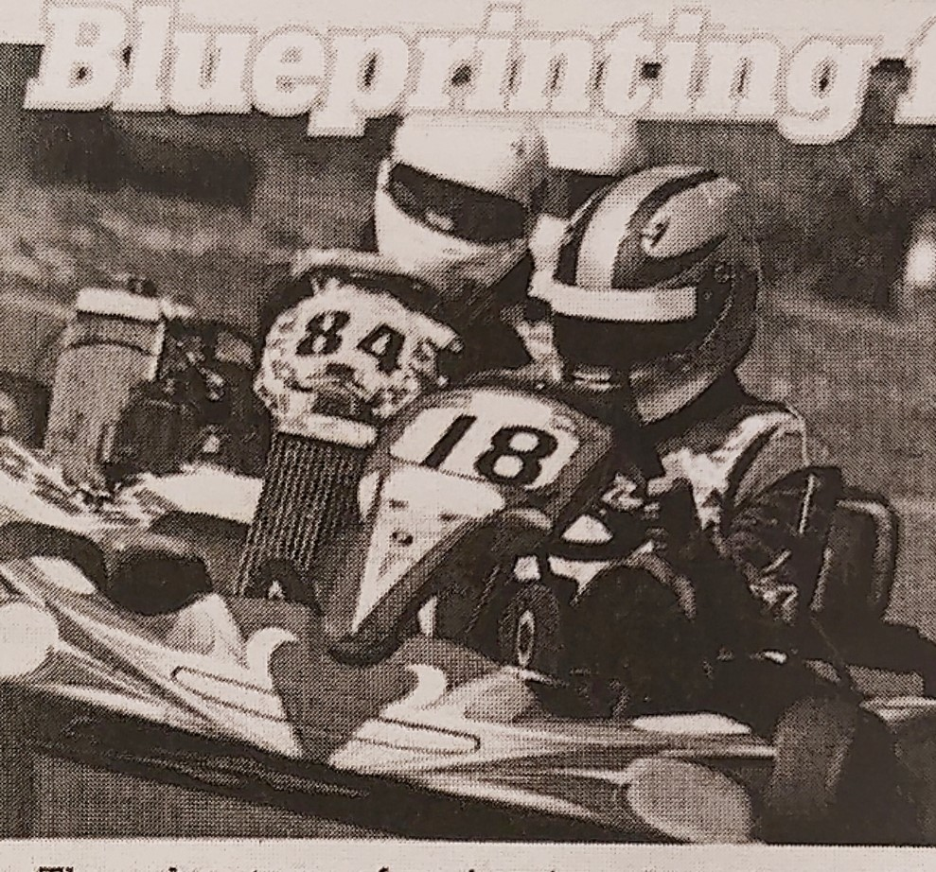

- Remove the lines of dots to solve the activities.
- Send the complete work to be checked to lorenzoncristina@gmail.com
- Deadline 27th May, 2021

