P R A C T I C A L W O R K # 4
CURRENT, VOLTAGE AND RESISTANCE.
- Electric current.

The photo at the end of the text A shows a simple electric circuit (or circuit). A cell provides an electric current (or current). This flows through wires, which conduct the electricity (provide a way for it to travel). The current is used to light a lamp. So, like all circuits, the example includes:

• an electrical supply - in this case, the cell

• an electrical conductor (or conductor)- an electrical path- in this case, wires

• one or more electrical components (or components)- electrical devices (in this case, the lamp) which have a function.

Current- measured in amperes, or amps (A) -is the rate of flow of electric charge. Electric charge is carried by electrons- particles with a negative charge (-), which are normally attached to atoms. When an electric current flows through a conductor; the electrons move from one atom to another- in the case of a copper wire, from one copper atom to the next. If the number of electrons flowing through a conductor increases, then the amperage, or ampage (current) increases. When electrons flow, carrying a current, they can be called charge carriers.

Notes: In everyday English, cells are called batteries. In technical English, a battery is a number of cells placed together.
Lamps are often called bulbs in everyday English.

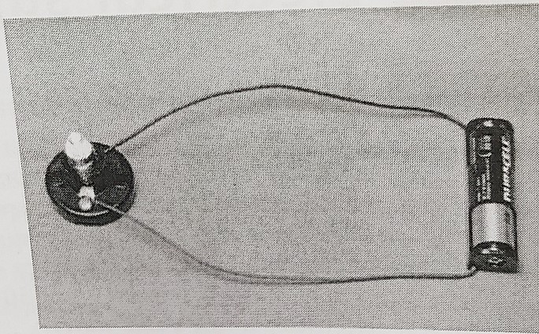

- Voltage and resistance.
The amount of current (in amps) flowing through a circuit will partly depend on the electromotive force (EMF) of the electrical supply. Electromotive force is measured in volts (V), and is generally called voltage. The voltage depends on the 'strength' of the electrical supply. In the diagram above, adding a second cell would supply a higher voltage.
The amount of current will also depend on electrical resistance (or resistance). This value - in ohms (Ω) - is a measure of how easily current can flow through the conductors and components in a circuit. For example, a lamp creates resistance because the filament- the metal wire inside it - is very thin. This limits the amount of current that can flow. Resistance also depends on the materials used as conductors. For example, copper has a low resistance and so is a good conductor.
Materials with very high resistance, such as plastics, are called electrical insulators (or insulators). Only very high voltages cause current to flow through them. Materials that are good insulators are used to insulate conductors. An example is plastic insulation around electric wires. This stops people from touching the conductor and- if it is live (carrying current) - from getting a dangerous electric shock.
- Electrical power.
The text below, about electrical power, is from a home improvements magazine.

The amount of current, in amps, required by an electrical appliance - such as a TV or an electric kettle - depends on the power of the appliance. This number - expressed in watts (W) - will be marked somewhere on the appliance. To calculate the required current, simply take the wattage and divide it by the voltage of the electrical supply in your home - around 230 volts in most of Europe. Therefore, for an electric kettle with a power rating of 2,000 watts (as specified by the manufacturer), the current required is: 2,000 watts = 8. 7 amps
230 volts

A C T I V I T I E S

Task 1: Complete the word puzzle and find the word going down the page. (Complete el crucigrama y encuentre la palabra en las referencias). Look at A, B and C to help you.

1- another term for amperage
2- provided by a battery, for example
3- measured as a wattage
4- allows current to flow through it
5- has very high electrical resistance
6- carried by moving electrons
7- another term for an electrical 'device'
8- the consequence of a person touching a live conductor

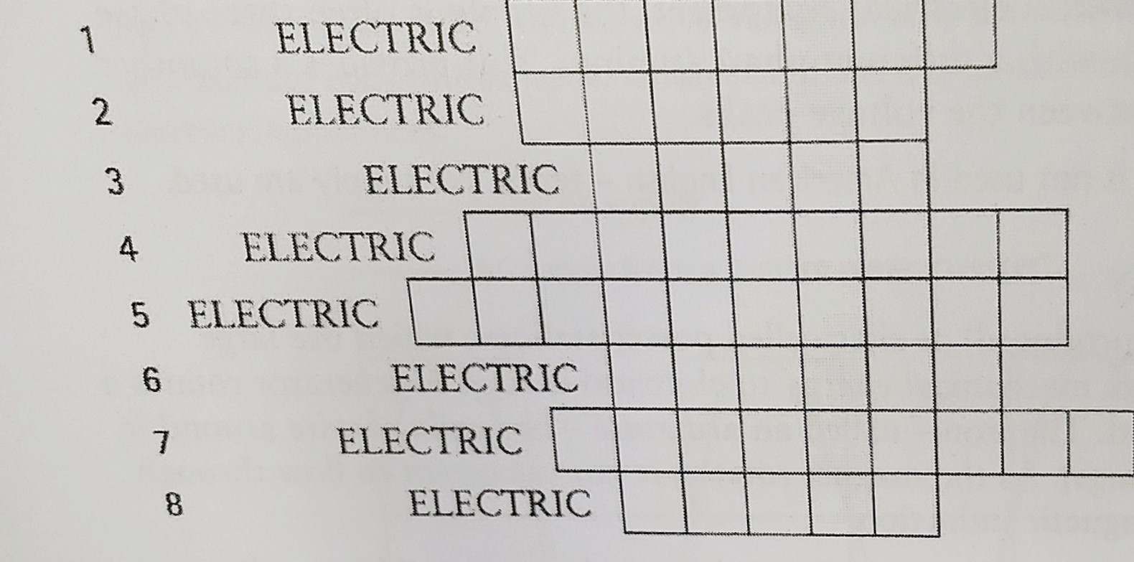

Task 2: Complete the extract about current and power calculations using the words in the box. (Complete el extracto acerca de los cálculos de potencia y corriente usando las palabras del cuadro) Look at A, B and C to help you.
amps – components - conductor - circuit - current - ohms - resistance - supply - voltage volts - wattage - watts

In electrical calculations, electromotive force is expressed by the letter E, resistance by the letter R, and current by the letter I (which comes from the word 'intensity').
According to Ohm's Law: I = E/R.
In other words, the (1) ................................ flowing through a (2) ................................, measured in (3) ................................, equals the ( 4) ................................ of the electrical (5) ................................, measured in (6) ................................, divided by the total (7) ................................, measured in (8) ................................. To work out the value of R, it is necessary to calculate the total resistance of all the (9) ................................ and connecting lengths of (10) ................................ that make up the circuit.
Once both the voltage and amperage are known, it is possible to work out the power, measured in (11) ................................, that will be consumed. Power (P) can be calculated using the equation P = EI. Therefore (12) ................................ equals voltage multiplied by amperage.

Send the complete work by email to be checked.
Deadline 26th August.

