UNIT 1: Hazards
DATE: 23rd April
- Look at the pictures, write the hazard and then choose the correct option.
1. LOUD NOISE | A. SAFETY HAZARD
 | B. ERGONOMIC HAZARD
 | C. PHYSICAL HAZARD
2. FIRE | A. SAFETY HAZARD
 | B. PSYCHOLOGICAL HAZARD
 | C. PHYSICAL HAZARD
3. UNSAFE ELECTRIC CIRCUIT | A. CHEMICAL HAZARD
 | B. PHYSICAL HAZARD
 | C. SAFETY HAZARD
4. HEAVY LIFTING | A. PHYSICAL HAZARD
 | B. ERGONOMIC HAZARD
 | C. CHEMICAL HAZARD
5. VIRUS/BACTERIA/GERM | A. PHYSICAL HAZARD
 | B. CHEMICAL HAZARD
 | C. BIOLOGICAL HAZARD

6. TOXIC MATERIAL | A. BIOLOGICAL HAZARD
 | B. SAFETY HAZARD
 | C. CHEMICAL HAZARD
7. COLD (EXTREME TEMPERATURE) | A. BIOLOGICAL HAZARD
 | B. PHYSICAL HAZARD
 | C. PSYCHOLOGICAL HAZARD
8. SLIPS | A. SAFETY HAZARD
 | B. ERGONOMIC HAZARD
 | C. PHYSICAL HAZARD
9. SEXUAL HARASSMENT | A. ERGONOMIC HAZARD
 | B. PSYCHOLOGICAL HAZARD
 | C. CHEMICAL HAZARD
10. FALL | A. PHYSICAL HAZARD
 | B. CHEMICAL HAZARD
 | C. SAFETY HAZARD

- Match the sentences below to the pictures.

- There is a hole in the floor. Someone could fall. 2
- The floor is wet. Someone might slip. 3
- There is a cord across the walkway. Someone could trip. 1
- The step is broken. Someone may fall. 4

- Match the hazards to the correct picture. Then, write the consequences using modal verbs. Sometimes, more than one option is possible. Use the collocation dictionary to use the verbs and nouns correctly and any other dictionary to work with translations. There is an example.
WET FLOOR – HEAVY LIFTING – OVEREXPOSURE TO THE SUN – INCORRECT POSTURE – HOT SURFACE – UNGUARDED MACHINE – EXTREME HEAT | BACKACHE – DEATH – RASH – BURNS – FALLS AND HITS – INJURY – SORE EYES – DIZZINESS – BROKEN BONES

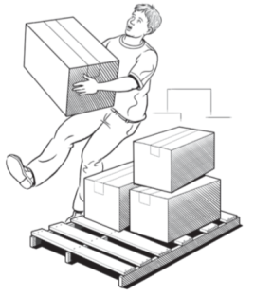
Heavy lifting: Someone could suffer from backache.

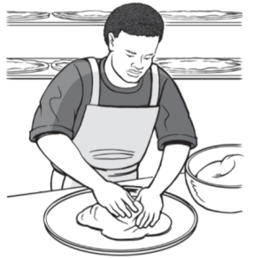
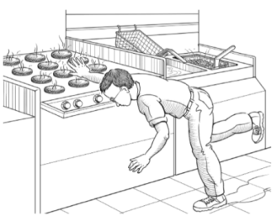
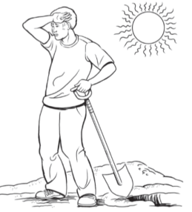
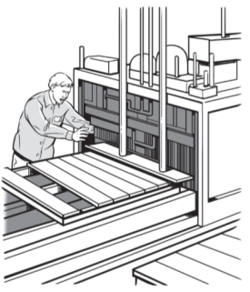
HOT SURFACE
WET FLOOR
Someone MIGHT slip or burn his hands.
OVEREXPOSURE TO THE SUN
EXTREME HEAT
Someone MAY suffer from dizziness or sore eyes.
.
INCORRECT POSTURE
Someone COULD suffer from backaches.
.
UNGUARDED MACHINE
Someone COULD suffer from broken bones.
Someone could die.

