*Term Exam II – Unit 2: PPE*

*Deadline: 18th June 2021 (6:30 pm)*

*Name/s: ………………………………*

1. *Read the safety poster and then mark the following statements as true (T) or false (F).*



1. Safety glasses should be worn if needed. ____
2. Arc flash clothing helps if there is an explosion. ____
3. Hold a hot stick when working with dead wires. ____
4. *Match the words (1-7) with the definitions (A-G).*
5. *What PPE are these workers wearing?*

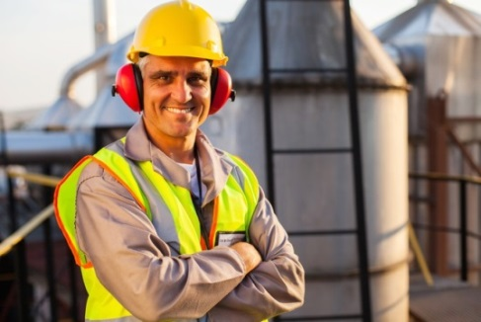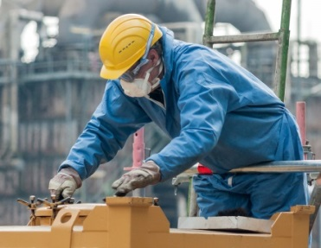

1. …………………

2. …………………

3. …………………

1. …………………

2. …………………

3. …………………

4. …………………

5. …………………

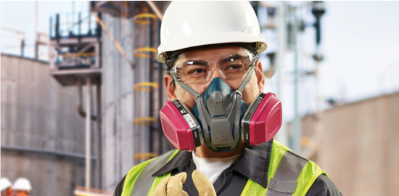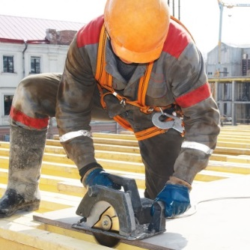

1. …………………

2. …………………

3. …………………

4. …………………

5. …………………

1. …………………

2. …………………

3. …………………

1. *Look at the pictures and match the safety equipment with its definition.*

|  |  |
| --- | --- |
| *SAFETY EQUIPMENT* | *DEFINITION* |
| Moldex 9001 Full Face Mask - Small   1. A protective mask   SAFETY SHOES steel toe (069) | Shopee Philippines   1. Safety shoes   Northrock Safety / Comfort Ear Protector, Comfort Ear Protector ...   1. Ear protectors   Protective Apron - Protective Cotton Apron Manufacturer from Mumbai   1. A protective apron   Safety Harness Five point Type Systemic Safety Belt With Double ...   1. A safety harness   Heat Resistant Safety Gloves | Durston Tools   1. Safety gloves   Construction Industrial Safety Helmet Suspension - Buy China ...   1. A safety helmet   TSG TSG Force V Knee Pads - Sucker Punch Skate Shop   1. Knee pads   Products | Height Protection | Harnesses and belts | Marca ...   1. A dorsal belt   SuperMore Anti-Fog Protective Safety Goggles Clear Lens Wide ...   1. Safety goggles | 1. handles heavy materials and protects the back. 2. avoids the worker falling. 3. protects the body against welding work. 4. protects ears against noise. 5. protects from inhaling harmful air particles as dusts, vapours, fumes and gases. 6. provide protection to the eyes. 7. protects the head from accidental injury. 8. handles heavy materials such as breeze-blocks, beams and avoids injuries. 9. protect the feet from accidental injury. 10. protect knees on the ground while working. |

1. Look at the picture and complete the chart.

|  |  |  |  |
| --- | --- | --- | --- |
| **PICTURE** | **PPE** | **BODY PART** | **EXAMPLE** |
|  |  |  |  |
|  |  |  |  |
|  |  |  |  |
|  |  |  |  |
|  |  |  |  |