PRACTICAL WORK # 5. ENERGY
(16th September class)
- Forms of energy
The effects of energy can be seen, felt or heard in different ways, depending on the form of energy in question. The main forms are listed below:
- kinetic energy: energy in the form of movement - a type of mechanical energy
- thermal energy: energy in the form of heat
- electrical energy: the energy of an electric current
- sound energy: energy in the form of noise
- light energy: for example, light emitted from the sun or from a light bulb
- chemical energy: energy within substances that can produce a chemical reaction
- nuclear energy: energy from an atomic reaction.

Energy cannot be created or destroyed, only converted from one form to another. For example, in a torch powered by batteries, chemical energy stored in the batteries is converted to electrical energy, and the electrical energy is converted to light energy.
Mechanical energy can be stored as potential energy. An example is a load, lifted by a crane and suspended at a high level. The weight has the potential (in the future) to be released and allowed to fall, becoming kinetic energy. Energy can also be stored when a component is elastically deformed. This is called strain energy. An example is the spring in a watch, which is wound up, then progressively unwinds.

- Energy efficiency
Machines often convert an energy source, such as electricity, to another form of useful energy - in other words, energy used for a purpose. For example, a motor converts electrical energy (the energy source) into kinetic energy (useful energy). But it also converts some energy into heat and noise. As this will be dissipated into the air, and not used, it is waste energy.

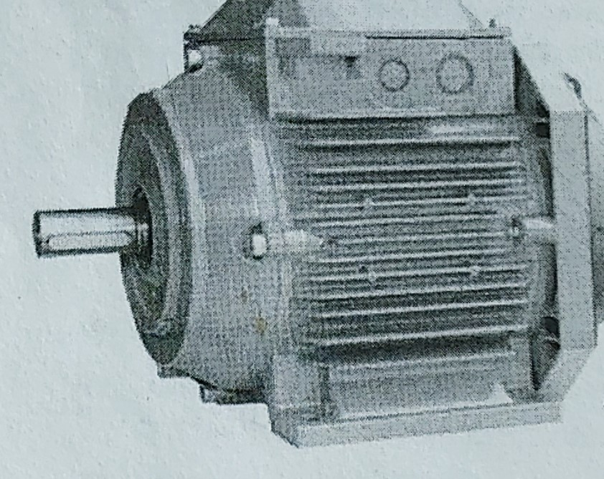
A motor: electrical energy ~ useful kinetic energy
~ wasted thermal and sound energy

If a machine converts a high percentage of energy into useful energy, it is efficient. For example, if a motor converts 7 5% of the electrical energy it consumes into kinetic energy, and wastes 25% as thermal and sound energy, it is seventy-five percent efficient. Improving efficiency - making efficiency gains - is a key focus in engineering.

- Work and power
The amount of energy needed to do a task - for example, lifting a load to a certain height by crane - is called work. The amount of energy converted in order to perform tasks - in other words, the amount of work done - is measured in joules (J). If a force of one newton is required to keep an object moving, the work required to move that object over a distance of one metre is equal to one joule.

The speed, or rate, at which work is done is called power, and is measured in watts (W). One watt is one joule per second. Power, in watts, is often referred to as wattage. A powerful motor will have a higher wattage than a less powerful one.

A C T I V I T I E S
Task 1: Make word combinations with energy using words from A and B opposite. Then match the combinations with the descriptions (1-8).
- ................................ energy= energy stored within the liquids or solids in a battery
- ................................ energy = mechanical energy in the form of movement
- ................................ energy = potential energy stored in a deformed material
- ................................ energy= energy converted to the form required for a purpose
- ................................ energy= energy converted to a form that cannot be used
- ................................ energy = the form of energy that shines, and can be seen
- ................................ energy= the form of energy that can be heard
- ................................ energy= energy that results in an increase in temperature

Task 2: Complete the article about electric and diesel-electric locomotives using the words in the box. Look at A, B and C to help you.
chemical efficiency form kinetic powerful thermal wattage
convert efficient gain power source useful work
dissipated electrical joules powered stored waste

An electric locomotive is one that is (1) ................................ by an external energy (2) ................................, most often via overhead electric lines. This differs from a diesel-electric locomotive, which has an onboard fuel tank and a diesel-powered generator to provide electricity for its motors. Purely electric power has numerous advantages over diesel-electric power, explaining the choice of electric locomotives for use in high-speed trains.
Firstly, an electric locomotive needs to carry neither a generator nor fuel. Its mass is therefore lower than a diesel-electric equivalent. This results in a significant efficiency (3) ................................, as the electric locomotive's smaller mass means less (4) ................................ is done - measured as a total number of (5) ................................ - on a given journey. For a comparable rate of acceleration, its motors are also required to provide less (6) ................................. As they use a lower (7) ................................, this means less (8) ................................ motors can be used, making them smaller, thus further reducing weight and improving (9) ................................. In addition, electric locomotives use only (10) ................................ energy.
This means there is no need to (11) ................................ energy from one (12) ................................ to another on board the train (electricity can be generated more efficiently in power stations).
In a diesel-electric unit, the energy conversion process starts with (13) ................................ energy, which is (14) ................................ within the hydro-carbon compounds of diesel. This fuel is burned to produce (15) ................................ energy, and the heat is then converted by the engine into (16) ................................ energy, which provides the movement to drive the train. This process is a very long way from being 100% (17) ................................ - only a small percentage of the initial chemical energy is converted to the (18) ................................ energy that is actually used to drive the train, with a significant percentage being (19) ................................ into the air in the form of heat, constituting (20) ................................ energy.

Send the complete work to be checked.
Deadline: 23rd September.

