PRACTICAL WORK # 6. FLUID DYNAMICS
21st October class
A - Fluid dynamics and aerodynamics
Fluid dynamics is the study of how gases and liquids flow around objects. The branch of fluid dynamics concerned with airflow - called aerodynamics - is relevant to the design of aircraft, vehicles and structures. Aerodynamic tests can be done in wind tunnels - tunnels through which air is blown at high velocity. Analysis can also be done using computational fluid dynamics (CFD) -computers with complex simulation software.
B - Drag
Aerodynamic drag (or drag) is the resistance of an object to an airflow. It is measured by the drag coefficient. Objects with a low drag coefficient have little force exerted on them by an airflow. We say they are streamlined. There are different types of drag:
- Form drag is due to the shape of the object.

- Skin friction is the drag caused by air flowing over the surface of the object.

- Pressure drag is the pressure differential between the air upstream of the object (flowing towards it) and the air downstream of it (flowing away behind it). The lower-pressure zone close behind a moving object is often called the slipstream.

- Interference drag depends on the amount of turbulence around the object.

C - Laminar flow and turbulent flow
In aerodynamics, engineers focus on the airflow in the boundary layer - the air close to the surface of an object. If the object is streamlined, the airflow in the boundary layer will be laminar, following a direct, clean path. With a less streamlined object, the airflow will be turbulent, flowing in a disturbed, messy fashion. A turbulent flow produces more drag than a laminar flow, and generates a bigger wake - that is, the V-shaped zone of turbulent air behind the object. Wakes contain vortices. A vortex is a twisting flow - like water going down the plughole in a bath.
D - Aerofoils
Aerofoils are components designed to make air flow in specific ways. They include:
- aircraft wings, which generate lift - that is, upward aerodynamic force.

- the blades of plane propellers, and helicopter rotor blades, which generate thrust to propel aircraft through the air.

- wings on racing cars, which generate downforce - downward aerodynamic force.

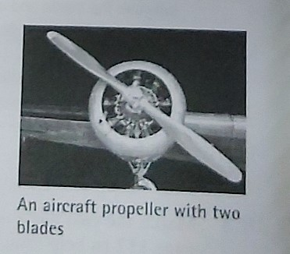

Aerofoils have specially designed profiles (cross-sectional shapes), often with their leading edge - the front edge, relative to the airflow - shaped differently to their trailing edge, at the rear. The behaviour of air around an aerofoil depends on the velocity of the airflow, and also on the angle of attack (or pitch) of the aerofoil - its angle relative to the airflow.

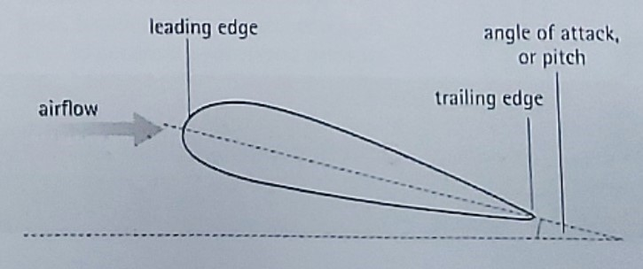
The section of an aircraft wing - an example of an aerofoil.

A C T I V I T I E S

TASK 1: Sort the terms in the box into categories (1-5). Look at A, B, C and D to help you. (Clasifique los términos en el cuadro en las categorías de 1 a 5. Mire A, B, C y D para ayudarse)

CFD downforce form drag lift rotor skin friction slipstream wake wind tunnel wing

1- Types of aerodynamic resistance:.............................and ...........................
2- Aerodynamic forces acting in specific directions:.........................................
and………………………
3- Aerodynamic effects downstream of an object:.................................. and
..........................................
4-Types of aerofoil: a ...............................and a ...............................................
5- Aerodynamic analysis tools:................................and a ............................

TASK 2: Use one term from each category in the previous activity to complete the sentences below. Look at A, B and C to help you. (Use un término de cada categoría en la actividad anterior para completar las oraciones de abajo. Mire A, B y C para ayudarse)
- The widening zone of turbulent air behind a fast-moving vehicle is called the………………………….
- In very strong winds, the low pressure generated just above the sheltered sides of the roofs of buildings generates ........................................., which can cause the roof to 'explode' outwards due to the higher-pressure air inside the building.
- The aerodynamic effectiveness of designs can be tested in a .................................................
- On an aircraft fuselage, the heads of rivets are designed to be as flat as possible in order to limit ................................................
- Most helicopters have either two or three main .........................................

TASK 3: Use the words in the box to complete the article, taken from a popular science magazine. You will need to use some words twice. Look at B, C and D to help you. (Use las palabras del cuadro para completer el artículo sacado de una revista popular de ciencia. Necesitarás usar algunas palabras dos veces. Mire B, C y D para ayudarse)

aerofoil airflow angle attack boundary downforce drag flow laminar layer leading pitch trailing turbulent

In aerodynamic-speak, the term 'spoiler' is slightly confusing, as it has two different meanings. In automotive engineering, a spoiler is a wing-like (1) ................................ on the back of a car. Unlike the wings on racing cars, the purpose of spoilers on road cars is not to generate (2) ................................ , but to 'spoil' or disrupt the (3)...............................within the (4) .................................. - the air close to the surface of the car's body. While this may seem strange, by turning what would otherwise be a smooth, (5) ............................................. into a messy, (6) ......................................... ,the car's (7) ...........................coefficient can be reduced, and the vehicle's handling can be made more stable at higher speeds.
In aeronautical engineering, spoilers - also called air brakes - are aerofoils mounted on the tops of an aircraft's wings. When deployed - most often at the moment a plane lands - they rotate in an angular motion, with their (8) ................................ edge (near the front of the wing) acting as a pivot, while the (9) ............................... edge (at the rear) lifts, increasing the spoiler's (10) .................................
Spoilers serve a dual purpose. Firstly, they generate (11) ................................, helping to push the aircraft down onto the runway. Secondly, they create (12) ................................, increasing air resistance and helping to slow the aircraft down.
Spoilers are therefore different to flaps, which are deployed from the rear of an aircraft's wings as it descends and slows down before landing. Flaps are rotated downwards, at a progressively increasing (13)................of .............................., in order to provide increased lift at lower speeds.

Remove the lines of dots to solve the activities.
Deadline: 28th October, 2021

