PRACTICAL WORK # 7. FLUID PRESSURE
(28th October class)

A- Gauge pressure and absolute pressure
Pressure is the amount of force acting on an area. When fluids (liquids or gases) are under pressure they exert pressure on the surfaces of the tanks, pipes, etc., that hold them. Examples of pressurized fluids are compressed air inside air hoses, compressed gases such as propane in gas cylinders, and water in water mains. The SI measurement of pressure is the Pascal. One Pascal is equal to one newton per square metre (1 Pa = 1 N/m2). However, many pressure gauges (devices which measure pressure) use the imperial measurement pounds per square inch (psi). Pressure can also be measured in bars. One bar is roughly equal to atmospheric pressure - that is, the pressure of the air in the atmosphere- at sea level. For example, four bars, or four bar - which can also be described as four atmospheres - is four times atmospheric pressure.
When engineers calculate the pressure of a fluid inside a vessel, they usually calculate its gauge pressure. This is the pressure differential - the difference in pressure - between the fluid inside the vessel and atmospheric pressure outside. Therefore, with gauge pressure, it is assumed that the atmosphere has a pressure of zero Pascals - even though this is not true (see below). Engineers use gauge pressure because they need to know if a fluid inside a vessel is at a higher pressure or at a lower pressure than the outside air (the air in the atmosphere), and if it is, by how much. This allows them to design tanks and pipes so that they do not fail dangerously by exploding if their gauge pressure is positive, or by imploding if their gauge pressure is negative. Pressure can also be measured by comparing it with a vacuum - a void containing no gas or liquid, as in space, where pressure is truly zero Pascals. Pressure compared with a vacuum is called absolute pressure. The absolute pressure of the atmosphere at sea level is approximately 100,000 Pascals (or 100 kilo-Pascals). Therefore a partial vacuum - which is below atmospheric pressure but is not a perfect vacuum - has a positive pressure when it is measured as an absolute pressure, because it has a higher pressure than a perfect vacuum. But it has a negative pressure when it is measured as a gauge pressure, because it has a lower pressure than the atmosphere.

B- Hydrostatic pressure and siphonic action

In liquids - most often in water - pressure and flow can be generated by hydrostatic pressure. An example is a water tower which supplies drinking water to homes. Water is stored in the tower at a high level, so that the water pushes down. This is called a head of water. It puts the water at lower level (in the water main) under pressure. If the height of the water tower is increased, this will increase the water pressure at low level. Smaller tanks located at a high level to generate hydrostatic pressure - at the tops of buildings, for example - are called header tanks.

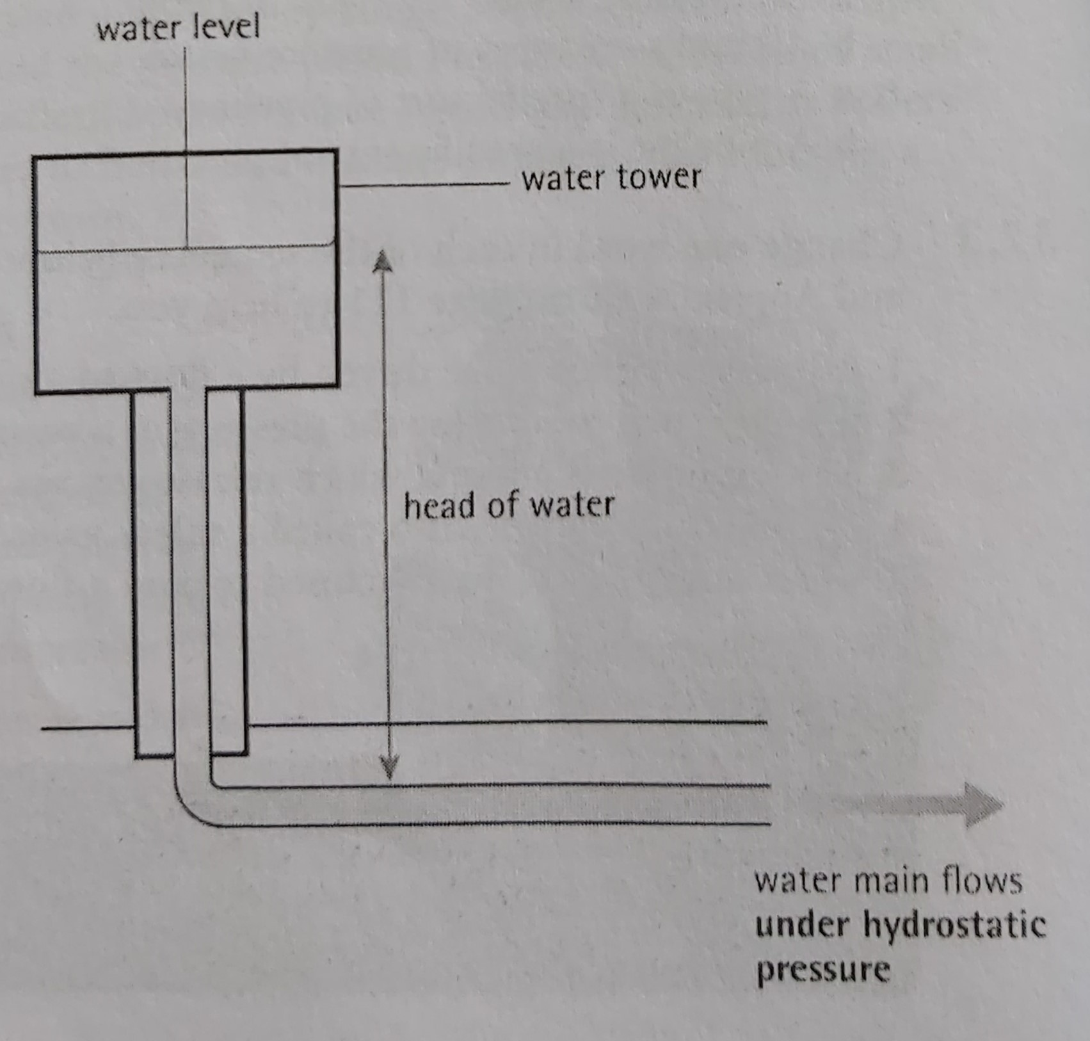

Note: See Appendix X for a description of siphonic action.
Siphonic action
Hydrostatic pressure allows liquids to be siphoned. The principle of siphonic action can be shown using a hose - called a siphon in this situation - to make liquid flow upwards from its surface level, over the side of a tank and then downwards. The hose must first be primed - that is, completely filled with water. The top end of the hose must then be immersed in the liquid (put below the surface). The bottom end may also be immersed, although this is not necessary. When the flow begins, the liquid in the hose must run at full bore- that is, the bore of the hose (its inside diameter) must be completely filled with water, with no air in it. Siphonic action is often used to drain rainwater from the roofs of large buildings. Unlike normal rainwater pipes, the pipes of siphonic drainage systems are designed to run at full bore, which allows them to flow much faster. This means smaller-diameter pipes can be used. These take up less space in the building.

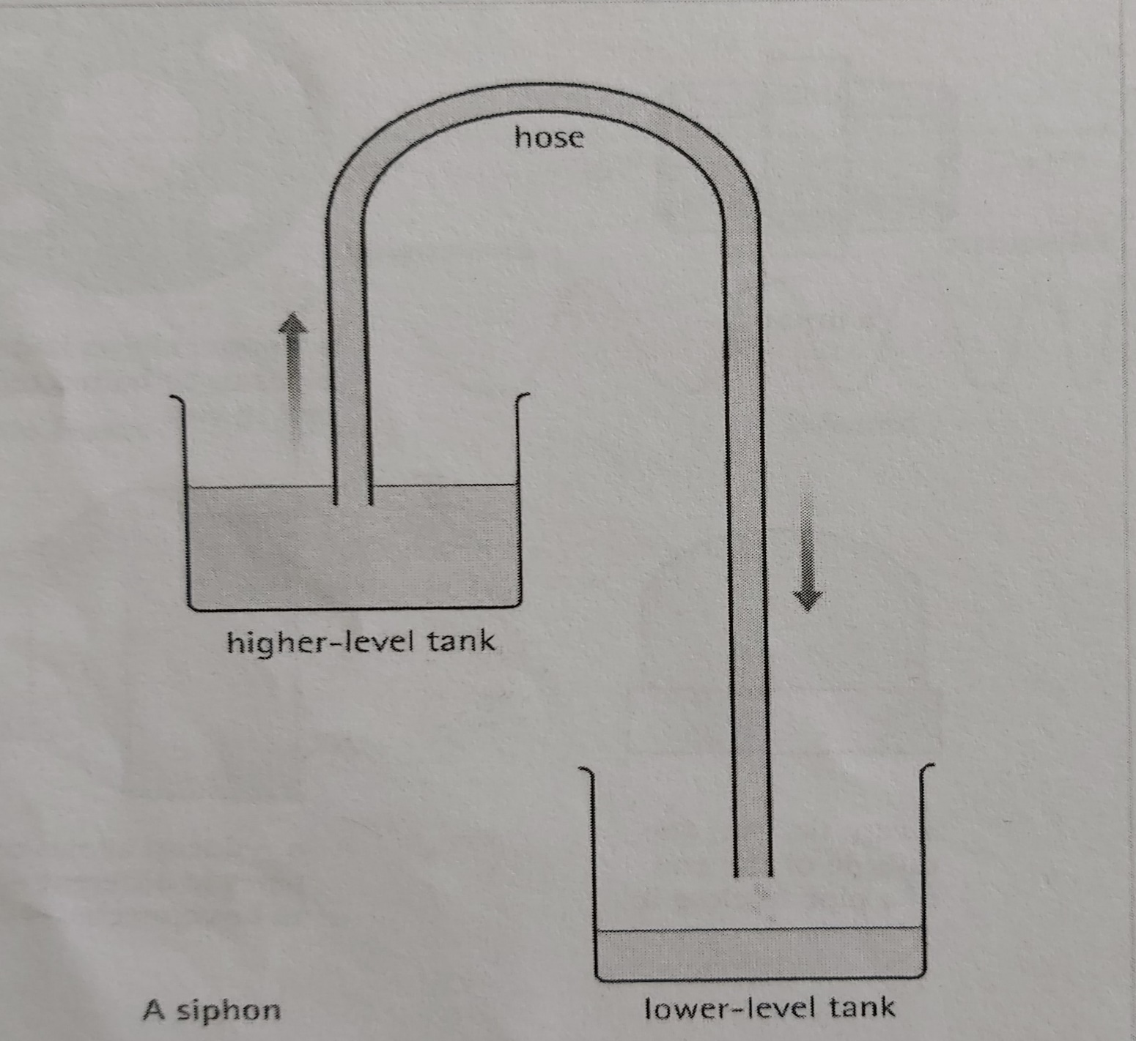

A C T I V I T I E S

TASK 1: Complete the sentences using the words “positive, negative and zero”. (Complete las oraciones usando las palabras “positive, negative y zero”)
- In a perfect vacuum, absolute pressure is ................................and gauge pressure is ................................
- In a partial vacuum, absolute pressure is ................................and gauge pressure is ................................
- At atmospheric pressure, absolute pressure is ................................ and gauge pressure is………………….
- In compressed air, absolute pressure is ................................and gauge pressure is ................................

TASK 2: Use the expressions in the box to complete the article about pressurized aircraft cabins, taken from an engineering journal. Look at A to help you. (Use las expresiones del cuadro para completar el artículo acerca de cabinas presurizadas de aeronaves, sacado de un semanario de ingeniería. Mire texto A para ayudarse.)

at a higher pressure at a lower pressure atmospheric pressure
compressed air exert pressure on explode gauge pressure
one atmosphere pressure differential pressurized
outside air

Ever wondered about… pressurized aircraft cabins?
It's a well-known fact that the cabins of commercial aircraft are (1) ................................. This is an obvious requirement, given that at high altitude the air is (2) ................................ than (3) ................................ at ground level. If passengers were exposed to these conditions while flying at altitude, they would suffer numerous health problems. Hence the need, at high altitude, to maintain the air inside the fuselage (4) ................................ than the (5) ................................. But how is this achieved and controlled?
At the moment an aircraft's doors are closed at the airport, the cabin pressure is clearly equivalent to (6) ................................, meaning the (7) ................................ of the cabin is zero. Once the aircraft takes off and begins to climb, the pressure of the outside air will begin to decrease, while air pressure inside the aircraft remains the same thanks to the airtight fuselage.
However, maintaining the air pressure simply by keeping the same air inside the aircraft for the duration of a flight would be problematic- firstly because the air needs to be continually renewed for the comfort of passengers, and secondly because at very high altitude the significant (8) ................................ between the inside and outside of the cabin would (9) ................................ the inside of the fuselage to an unacceptably high degree. Although the resulting stresses would not be high enough to cause the fuselage to (10) ................................, they would result in a high rate of metal fatigue. Consequently, as the aircraft climbs, air is released through valves in the fuselage until a slightly lower pressure is attained - equivalent to the pressure of the outside air at an altitude of between 5,000 and 8,000 feet. Air is then constantly renewed during the flight by releasing it through the valves, and replacing the equivalent volume with (11) ................................ pressurized to the same level by the aircraft's engines.

TASK 3: Match the two parts to make correct sentences. Look at B and Appendix X Siphonic action to help you. (Una las dos partes para armar oraciones correctas. Mire B y Apéndice “Siphonic action” para ayudarse)
- Header tanks are designed to
- To prime means to
- Siphonic action is able to
- Water towers are large tanks designed to

- make liquid flow upwards from its surface.
- generate hydrostatic pressure in a building.
- supply large numbers of buildings.
- fill a pipe or hose to its full bore, removing the air.

Deadline 4th November

